FAKE NEWS DETECTION SYSTEM USING FEATURE BASED OPTIMISED MSVM CLASSIFICATION
Methodology, Novelty and Key Contributions
Department of Computer Science and Engineering, [COLLEGE NAME]
Batch C6 (CSE-C) · Academic year [ACADEMIC YEAR]
Table 1: Project team
S.No. | Student name | Roll number
1 | Neela Mojes | 23K91A05H1
2 | Noor Saniya | 23K91A05H4
3 | Malkajgiri Akshitha | 23K91A05E2
4 | Maravajhala Radha Sri Aashritha | 23K91A05E7

Project guide: K Rajasekhar Rao
Chapter and section numbers quoted in the text (for example Chapter 8 or Section 6.2) refer to the full project report, 17.Final Document. Figures and tables in this document are numbered from 1.

1. METHODOLOGY
This document describes how the fake news detection system (TruthGlow) works from end to end and what is new in it. Part 1 gives the pipeline, the data, the algorithms and the reasons they were chosen; Part 2 sets the work against the base paper and separates what is new from what is standard; Part 3 lists the contributions.

1.1 Overall methodology
The method is a classical supervised text-classification pipeline in which every stage is chosen to keep the model small and cheap to run on a CPU. A news statement is cleaned, turned into a sparse vector of word and word-pair weights (TF-IDF) and 25 hand-built stylistic measurements, standardised, compressed by Principal Component Analysis (PCA), and then classified by a multi-class Support Vector Machine (MSVM) with a radial-basis-function (RBF) kernel. The Firefly algorithm, a population-based metaheuristic, searches jointly for the subset of PCA components to keep and for the SVM parameters C and gamma [6, 7]. The classifier outputs one of three verdicts: REAL, PARTIALLY TRUE or FAKE, with a confidence. The steps are:
1. Assemble a labelled corpus of statements with a truthfulness label (LIAR2 for the real measurements, a synthetic template corpus for the shipped demo model).
2. Clean the text: lower-case, remove URLs, mentions and hashtags, keep letters only, drop stop words and tokens of two characters or fewer.
3. Featurise: TF-IDF over unigrams and bigrams (vocabulary capped at 4,000 terms in the experiments) plus 25 stylometric features, 4,025 columns in all.
4. Standardise every column and reduce with PCA (target 95 % of the variance, at most 300 components).
5. Split the reduced vectors 80/20 with a stratified split; the Firefly search sees only the 80 % part.
6. Optimise: the Firefly algorithm evolves a binary component mask and the values of C and gamma; a candidate's fitness is its 3-fold cross-validated macro-F1 minus a small penalty for the share of components kept.
7. Train and evaluate: fit the final RBF SVM with balanced class weights on the masked training part, score the 20 % hold-out, and fit a default-parameter SVM on all components as the baseline.
8. Save and serve: store the fitted vectoriser, scaler, PCA, mask, C, gamma, classifier and statistics in one .pkl bundle, used by the API, the command line and the Streamlit app.
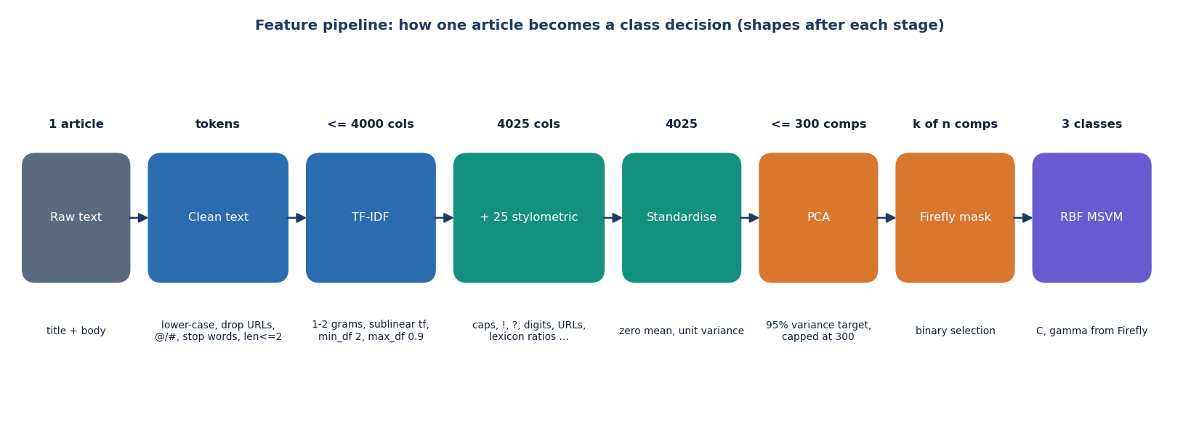
Figure 1: Shape of the data after each stage of the feature pipeline.
Evaluation protocol for the real-data results. The pipeline code is the product's own (src/pipeline.py, unchanged). For LIAR2 a stratified subsample of 3,000 statements is drawn from the 18,369-statement training split, the pipeline is fitted on it, and the fitted model is scored on the complete official validation (2,297) and test (2,296) splits. This is repeated for 3 seeds (2024, 42, 7); results are reported as mean and standard deviation. Beside the proposed pipeline the same test split scores (i) the default-parameter SVM on the same PCA space, (ii) an SVM using only the Firefly mask with default C and gamma, (iii) an SVM tuned by random search with exactly as many fitness evaluations as the Firefly run used and the same fitness function, (iv) three linear or probabilistic models on plain TF-IDF (complement naive Bayes, logistic regression, linear SVM) trained on the same subsample and on the full training split, and (v) a majority-class predictor. The subsample size is a compute limit: a Firefly run needs about 550 cross-validated SVM fits.

1.2 Dataset

1.2.1 LIAR2: the dataset behind every real measurement
LIAR2 is a benchmark of about 23,000 short political statements checked by professional fact-checkers, released by Xu and Kechadi [4] as an extension of the LIAR dataset of Wang [5]. It was downloaded from the Hugging Face dataset chengxuphd/liar2 (licence Apache-2.0) and is not redistributed with the submission; data/liar2/ holds the downloaded CSV files. The official 8:1:1 split gives 18,369 training, 2,297 validation and 2,296 test statements, with an average of about 17.7 tokens per statement. Each statement carries one of six labels: pants-on-fire, false, barely-true, half-true, mostly-true, true. Only the statement text is used. The CSV also holds speaker, subject, justification and per-speaker historical counts of past ratings; these were deliberately left out because they leak the label (the justification is the fact-checker's verdict text, and the speaker counts record how often the same speaker was rated false) and would not exist for a new claim.
Table 2: Mapping from the six LIAR2 labels to the three classes of the product
LIAR2 label (id) | Project class | Statements in the whole dataset
true (5), mostly-true (4) | REAL | 2,585 + 3,429 = 6,014
half-true (3) | PARTIALLY TRUE | 3,709
barely-true (2), false (1), pants-on-fire (0) | FAKE | 3,603 + 6,605 + 3,031 = 13,239

The mapping follows the one coded in src/dataset.py for LIAR-style word labels (true and mostly-true are REAL, half-true is PARTIALLY TRUE, the rest FAKE). The experiment script applies the same rule to the numeric ids. The result is imbalanced: FAKE is the majority class. The test split holds 602 REAL, 371 PARTIALLY TRUE and 1323 FAKE statements, so a predictor that always answers FAKE is right 57.6 % of the time; the training subsample holds 786 / 484 / 1730. For this reason macro-F1, which weighs the three classes equally, is the headline metric and accuracy is always shown beside it.

1.2.2 The synthetic demo corpus
The repository also contains build_demo_dataset (src/dataset.py): a generator of a balanced three-class corpus from five sentence templates per class and ten topics, with a short phrase appended to about 30 % of the sentences. REAL templates read like official reports ("... confirmed by independent experts with verified data"), PARTIALLY TRUE templates mix a claim with doubt ("... but experts say evidence is partial"), and FAKE templates use clickbait words ("SHOCKING secret ... miracle ... click now"). The shipped model models/msvm_model.pkl was trained on 750 such documents (250 per class) with a hold-out of 150. Because the three classes differ in their template words alone, that model scores accuracy 1.000 and macro-F1 1.000 on its own hold-out (Firefly fitness 0.9916); it is a pipeline check and a way to run the application without a download. On the real LIAR2 test split the same model reaches accuracy 0.192 and macro-F1 0.155 and answers PARTIALLY TRUE for 2,044 of the 2,296 statements.
Table 3: The two data sources
 | LIAR2 (real) | Demo corpus (synthetic)
Source | Hugging Face chengxuphd/liar2, Apache-2.0 | build_demo_dataset, generated in code
Documents used to fit | 3,000 statements per run (subsample of 18,369) | 750 (250 per class)
Evaluation | Official test split, 2,296 statements; validation 2,297 | 20 % hold-out of the same templates, 150 documents
Class balance | Imbalanced: FAKE is 57.6 % of the test split | Balanced: 50 per class in the hold-out
What a high score means | Evidence about reading real claims | Only that the template words separate the classes

1.3 Preprocessing and feature construction

1.3.1 Text cleaning
clean_text (src/preprocessing.py) prepares text for the TF-IDF vectoriser. It lower-cases the text, replaces URLs (http://..., www...) and tokens that start with @ or # by a space, replaces line breaks and every character that is not an English letter by a space, collapses repeated spaces, splits on spaces and removes tokens that are stop words or have two characters or fewer. The stop-word list is a built-in set of 128 English function words, so no external download is needed. The function accepts any input: a non-string value returns an empty string. There is no stemming or lemmatisation; this differs from objective 2 of the project, which lists stemming, and is recorded as a deviation in Chapter 8. Because every non-letter is removed, digits and percentages ("58 percent", "9.4%") are discarded by the cleaner; they are still counted by the stylometric features, which read the raw text.

1.3.2 TF-IDF features
The cleaned text is vectorised with scikit-learn's TfidfVectorizer [14]: unigrams and bigrams, sublinear term frequency (1 + ln tf), terms must occur in at least two documents (min_df=2) and in at most 90 % of them (max_df=0.9), and the vocabulary is capped at max_features terms (4,000 in train.py, the Retrain screen and the experiments; 5,000 is the constructor default). Rows are L2-normalised. On the 3,000-statement training subsample the vocabulary reaches the cap, giving 4,000 TF-IDF columns [13].

1.3.3 The 25 stylometric features
stylometric_features computes 25 numbers per document from the raw (uncleaned) text. They describe style rather than topic: length, punctuation, capitalisation, digits, lexical variety and the density of words from three small built-in lexicons. Style cues are a recognised, if weak, signal of veracity and hyperpartisanship [21, 22, 20].
Table 4: The 25 stylometric features, in column order
# | Feature | Definition
1 | chars | Number of characters of the text
2 | n_words | Number of whitespace-separated words (at least 1)
3 | n_sent | Number of segments when splitting on . ! ? (at least 1)
4 | avg_wlen | Mean word length in characters
5 | uniq_ratio | Distinct words divided by words
6 | stop_ratio | Share of words that are stop words
7 | pos | Share of words from the positive lexicon (true, great, excellent, verified, confirmed, official, evidence, proven, real, accurate, trust)
8 | neg | Share of words from the negative lexicon (shocking, secret, unbelievable, miracle, hoax, conspiracy, exposed, urgent, breaking, viral, click, banned, hidden)
9 | sens | Share of words from the sensational lexicon (11 entries; "you wont believe" is a three-word entry that a single-token match can never hit)
10 | caps_ratio | All-capital words (two letters or more) divided by words
11 | upper | Count of all-capital words
12 | exclaim | Number of exclamation marks
13 | question | Number of question marks
14 | punct_ratio | Punctuation characters divided by characters
15 | words_per_sent | Words divided by sentences
16 | long_word_ratio | Share of words longer than 6 characters
17 | short_word_ratio | Share of words of 3 characters or fewer
18 | digit_ratio | Digits divided by characters
19 | exclaim_flag | 1 if more than 2 exclamation marks, else 0
20 | question_flag | 1 if more than 1 question mark, else 0
21 | url_flag | 1 if the text contains a URL
22 | urls | Number of URLs
23 | first_person | Share of words in {i, we, us, our, my}
24 | superlative | Share of words longer than 5 characters ending in "est"
25 | neg_minus_pos | neg minus pos

The features have very different scales, which is why the next stage standardises every column. The 4,025 columns are stored densely (about 100 MB for 3,000 documents), one reason the pipeline suits only corpora of a few thousand documents.

1.4 Algorithm choice and justification
Table 5: Why each component was chosen, and what the measurements say
Component | Role | Why chosen | What was found
TF-IDF (1-2 grams) | Sparse word and word-pair weights | Cheap, needs no pre-trained model or GPU, standard strong baseline for text [13, 19]; bigrams catch short phrases | Linear models on TF-IDF alone reach macro-F1 0.500 ± 0.000 (logistic regression, full training split)
25 stylometric features | Style signals: caps, punctuation, lexicon density | Cheap and interpretable; the lexicons also drive the cue words shown in the interface | Not ablated separately; their individual contribution is not measured
StandardScaler | Zero mean, unit variance per column | PCA and RBF-SVM are scale sensitive; stylometric columns are on very different scales | Also gives rare TF-IDF terms the same variance as common ones, which spreads variance over many components
PCA | Dense low-dimensional representation | The task statement asks for dimensionality reduction; shrinks 4,025 columns before the SVM [10, 11] | Cap of 300 components keeps only 29.3% of the variance on real text, far below the 95 % target
Firefly algorithm | Joint search of component mask, C, gamma | Metaheuristic that handles a mixed binary and continuous search space without gradients [6, 7, 25, 24] | Fitness 0.4334 against 0.4256 for equal-budget random search, but no clear gain on the test split (Chapter 8)
RBF multi-class SVM | Final classifier | Margin classifier that works well with a few thousand dense, moderate-dimension samples [8, 9] | Test macro-F1 0.429 ± 0.010
Balanced class weights | Rescales the penalty C per class | FAKE is the majority class; weighting counteracts imbalance without resampling [15, 1] | Raises recall of the minority classes at the cost of accuracy: the weighted model scores accuracy below the 0.576 majority baseline but macro-F1 above it (0.244)
Platt scaling (probability=True) | Class probabilities for the interface | The interface shows a confidence and a probability per class [12] | Probabilities and verdict disagree on 48.8% of the real test statements (Section 6.6.3)

Why not a transformer. The base paper's strongest system uses contextual transformer embeddings with a neural network on a GPU, reaching accuracy 95.52 % on a binary Arabic task [1]; fine-tuned transformers also dominate the comparison of Dell'Oglio et al. [2]. The gap named by this project is the opposite end of the trade-off: a pipeline that a student laptop can train and run without a GPU, whose cost is dominated by a search that can be shortened or switched off. The measurements in Chapter 8 test whether that cheaper pipeline keeps enough accuracy; the honest answer on LIAR2 is that it does not beat even simpler linear models, so the choice is justified by cost and transparency, not by accuracy.

1.5 Mathematical formulation

1.5.1 TF-IDF
For term t in document d, with n documents and document frequency df(t), scikit-learn's smoothed, sublinear weight is
w(t, d) = (1 + ln tf(t, d)) · idf(t), idf(t) = ln((1 + n) / (1 + df(t))) + 1 (1)
and each document vector is scaled to unit Euclidean length. Standardisation of every column j of the concatenated matrix is
z(i, j) = (x(i, j) − μ_j) / σ_j (2)

1.5.2 PCA
Let Z be the standardised n × p matrix and λ_1 ≥ λ_2 ≥ ... the eigenvalues of its covariance matrix. The principal components are the corresponding eigenvectors and the projection keeps the first k components, where k is the smallest number whose explained-variance share reaches 0.95, then limited to the range 10 to 300 (and to n − 1):
k = min( max(10, min(k_95, 300, n − 1)), p ), k_95 = min{ k : (λ_1 + ... + λ_k) / (λ_1 + ... + λ_p) ≥ 0.95 } (3)
On the LIAR2 subsample k_95 is far larger than 300, so the cap decides: k = 300 in every run and the retained variance is 29.3% ± 0.2%.

1.5.3 SVM with RBF kernel and class weights
The kernel and the weighted soft-margin problem for a binary sub-problem are
K(x, x') = exp(−γ ‖x − x'‖²) (4)
min over w, b, ξ : ½ ‖w‖² + C · Σ_i c(y_i) · ξ_i subject to y_i (wᵀφ(x_i) + b) ≥ 1 − ξ_i, ξ_i ≥ 0 (5)
c(k) = n / (K · n_k) (class_weight = "balanced", K = 3 classes, n_k = documents of class k) (6)
scikit-learn's SVC handles three classes by training K(K − 1)/2 = 3 one-versus-one binary classifiers and predicting by voting; the option decision_function_shape="ovr" used here only reshapes the decision values into one score per class and does not change the predicted label. The project's "MSVM" is therefore this one-versus-one machine with a one-versus-rest view of its scores [9].

1.5.4 Firefly search
Each firefly i is a vector x_i of length d = n_c + 2, where n_c is the number of PCA components: n_c mask logits followed by log10 C and log10 gamma. It is decoded as
m_k = 1 if sigmoid(x_ik) > 0.5 else 0 ; C = 10^clip(x_i,n_c+1, −1, 3) ; γ = 10^clip(x_i,n_c+2, −4, 1) (7)
(if no mask bit is set, the component with the largest logit is switched on). Brightness is the fitness: the mean macro-F1 of a stratified 3-fold cross-validation of the RBF SVM (balanced weights) on the masked training data, less a penalty on the size of the subset; a mask with fewer than two components scores 0:
f(x_i) = F1_macro^(3-fold)(m, C, γ) − 0.02 · |m| / n_c (8)
A less bright firefly i moves toward each brighter firefly j. The attractiveness decays with the squared distance r², normalised by the dimension, and a random step shrinks every generation g:
β = β_0 · exp(−γ_f · r_ij² / d) , r_ij² = ‖x_i − x_j‖² , α_g = α_0 · 0.97^g (9)
x_i ← x_i + β (x_j − x_i) + α_g · 2(u − ½) , u ~ Uniform(0, 1)^d (10)
with β_0 = 1, γ_f = 1 and α_0 = 0.2 (the absorption coefficient γ_f is the algorithm's own and is unrelated to the SVM's gamma). After each move the two hyper-parameter coordinates are clipped to their ranges and the firefly's brightness is recomputed, so every move costs one cross-validation. At the end of each generation the best vector so far is remembered and the dimmest firefly is replaced by that vector plus a small random step (elitism). The initial population is uniform in [−1, 1] for the mask logits, [−1, 2] for log10 C and [−3, 0] for log10 gamma. With 10 fireflies and 12 generations a run made seed 2024: 571, seed 42: 511, seed 7: 567 fitness evaluations.
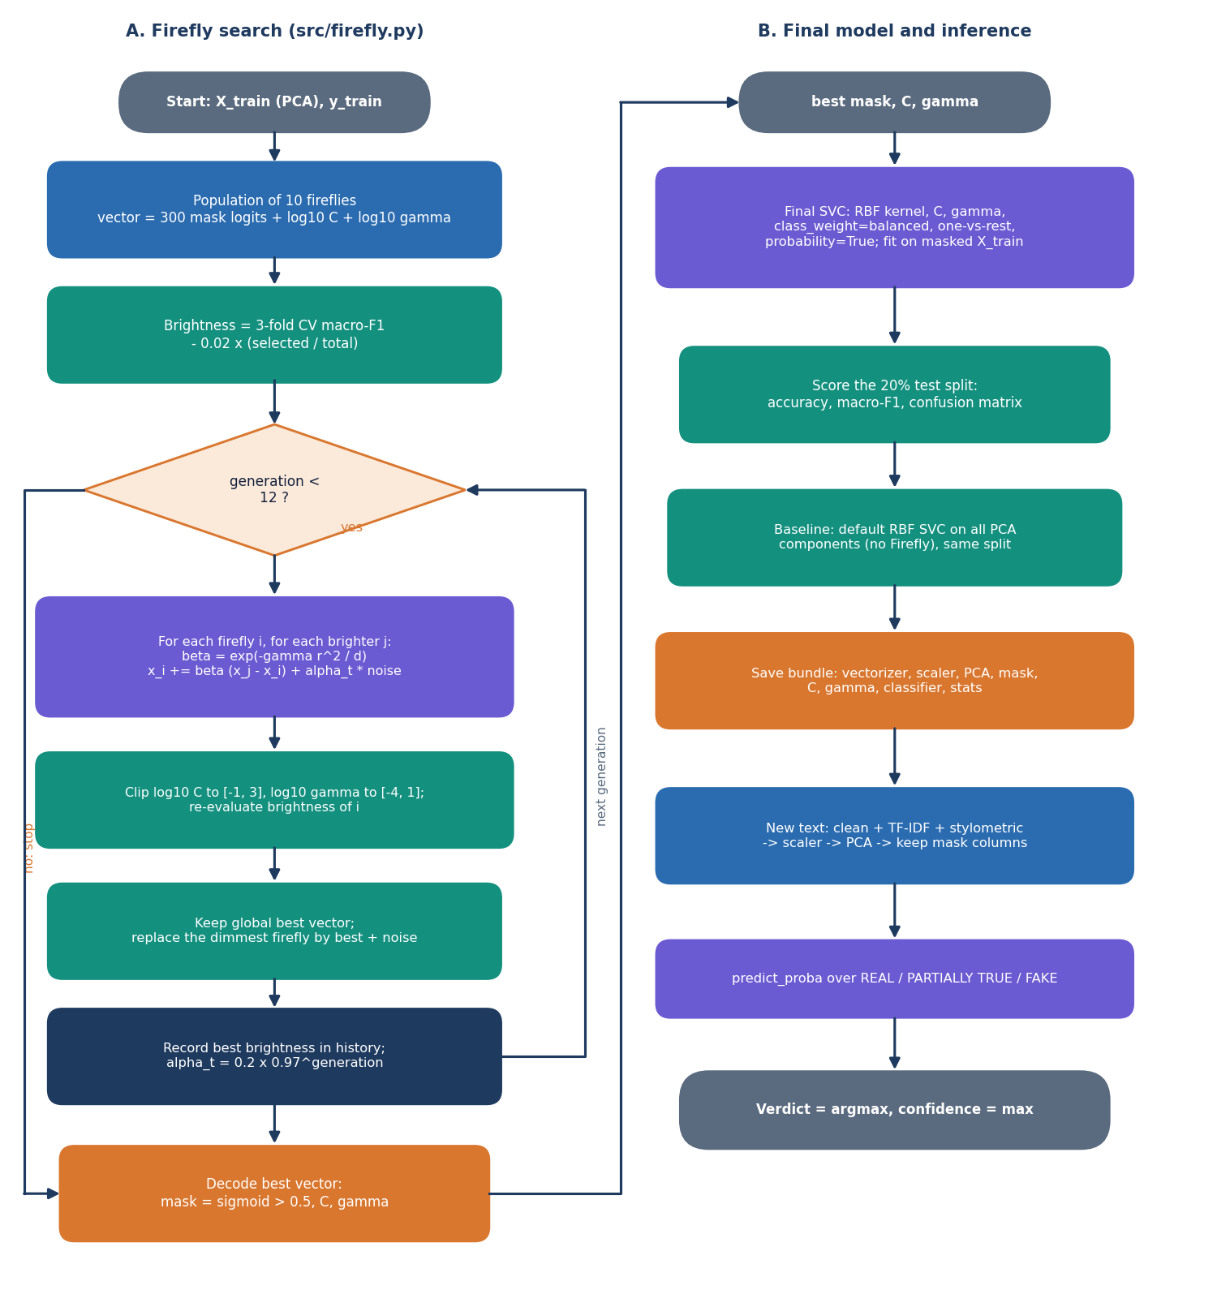
Figure 2: Flowchart of the Firefly search and of the final model.

1.5.5 Metrics and Platt scaling
P_k = TP_k / (TP_k + FP_k) , R_k = TP_k / (TP_k + FN_k) , F1_k = 2 P_k R_k / (P_k + R_k) , macro-F1 = (F1_1 + F1_2 + F1_3) / 3 (11)
Macro-F1 gives the small PARTIALLY TRUE class the same weight as FAKE. The class probabilities shown in the interface come from Platt scaling: libsvm fits a sigmoid to the decision values by an internal 5-fold cross-validation and couples the pairwise results into three probabilities,
P(y = 1 | f) = 1 / (1 + exp(A f + B)) (12)
The sigmoid is fitted on the original class frequencies, whereas the class-weighted decision function that produces the verdict is not; this is the origin of the disagreement documented in Section 6.6.3.

1.6 Model architecture and training configuration

1.6.1 Architecture of the trained model
The trained model is the chain vectoriser, scaler, PCA, mask, SVM. FakeNewsMSVMPipeline.save writes all of these, with the best mask, C, gamma and the statistics of the run, into one joblib file. load rebuilds the pipeline from the file, so the Firefly optimiser exists at prediction time only as its best mask. The data shrinks as in the figure below: 4,025 columns, 300 PCA components and 148 ± 12 selected components.
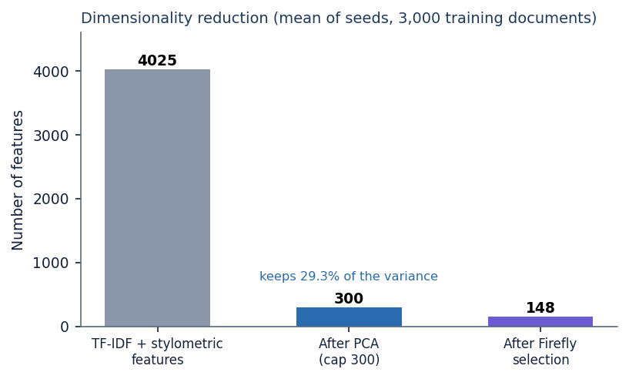
Figure 3: Feature counts after each stage (mean of three runs).
Table 6: Training configuration
Item | Setting
TF-IDF | ngram (1, 2), sublinear tf, min_df 2, max_df 0.9, max_features 4,000 (class default 5,000)
Stylometric features | 25 columns, concatenated: 4,025 in total
Scaling | StandardScaler, fitted on all training documents
PCA | 95 % variance target, at least 10 and at most 300 components (pca_max), random_state 42
Split | 80 / 20 stratified (test_size 0.2, random_state 42) of the PCA vectors
Firefly | 10 fireflies, 12 generations in train.py, the Retrain screen and the experiments (class defaults 12 and 15); α_0 0.2, β_0 1, γ_f 1, penalty 0.02, 3-fold CV, decay 0.97
SVM | kernel rbf, class_weight balanced, decision_function_shape ovr, probability True, random_state 42; C and gamma from the Firefly search
Baseline | SVC(class_weight="balanced") with default C = 1 and gamma = "scale" on all PCA components
Experiments | 3,000-statement stratified subsample, seeds 2024, 42, 7
Hardware | Intel Core i5-12500 (6 cores, 12 threads, 3.0 GHz), 15.7 GB RAM, Windows 11 Pro, no GPU used
Software | Python 3.11.9, scikit-learn 1.9.1, NumPy 2.4.6, SciPy 1.17.1, pandas 3.0.6, FastAPI 0.159.1, uvicorn 0.54.0, Node 24.19.0, React 18.3, Vite 8, TypeScript 5.9, Tailwind CSS 4

The vectoriser, scaler and PCA are fitted on all documents given to fit, including the 20 % held out inside the pipeline. This uses no labels, but it makes the internal hold-out score (shown on the Analytics screen) slightly optimistic; Chapter 8 therefore reports scores on the separate official test split. The final SVM is trained on the 80 % part only (2,400 of 3,000 statements).

1.6.2 What the search found
Table 7: Firefly results per run (10 fireflies, 12 generations)
Seed | Components kept (of 300) | C | gamma | Best fitness (CV) | Search + fit time (s)
2024 | 156 | 1.13 | 0.00094 | 0.4380 | 481
42 | 154 | 21.36 | 0.00061 | 0.4217 | 444
7 | 134 | 2.92 | 0.00152 | 0.4406 | 589

The three runs choose very different values of C (1.1 to 21.4) and about half of the components, which already suggests that the fitness surface is flat: many settings are almost equally good. the figure below shows the best fitness found in each generation. Most of the improvement comes in the first four generations. The search costs 504 ± 75 s per run, against 1.2 s for one default SVM fit; an equal-budget random search needs 480 s.
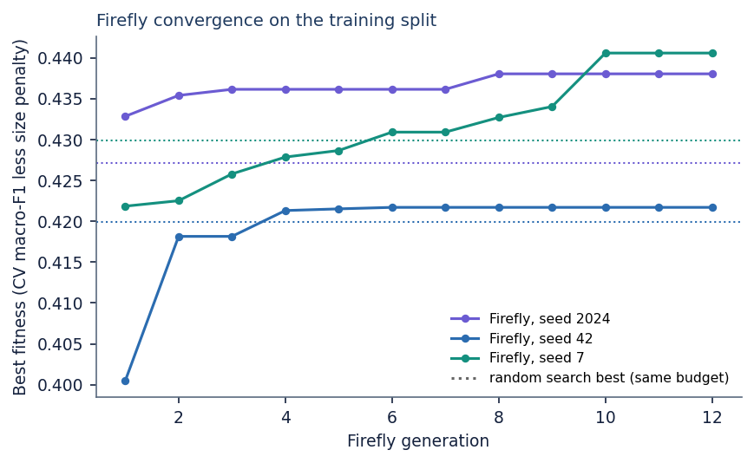
Figure 4: Best fitness per generation for the three runs; dotted lines mark the best fitness of the equal-budget random search of the same run.

1.6.3 Verdict and probabilities
predict returns two things: the class from SVC.predict, which uses the class-weighted decision function, and predict_proba, the Platt-scaled probabilities. The Detect screen displays the class as the verdict and the largest probability as the confidence. On real data the two differ: on 1,120 of 2,296 test statements (48.8%) the verdict is not the class with the highest probability, the probabilities name FAKE as the top class for 2,252 statements, and PARTIALLY TRUE is never the top-probability class (it is the verdict for 419 statements). Using the largest probability as the verdict would give accuracy 0.578 but macro-F1 only 0.264, because it almost always answers FAKE. The behaviour is documented as a limitation; no change was made to the code.

2. NOVELTY AGAINST THE BASE PAPER
The project does not propose a new learning algorithm and does not claim one. Principal component analysis, the Firefly algorithm and the support vector machine are all established methods [10, 6, 8]. What the project contributes is a particular combination of them, the way the combination is packaged as an application and, above all, a measurement of how well the combination works on real fact-checked text. This document states first how the work differs from the base paper, then what is and is not new, and finally what the evidence supports.

2.1 Difference from the base paper
Table 8: The base paper and this project compared
Dimension | Base paper (Saad et al. 2026) [1] | This project | What differs
Problem | Arabic fake news detection, binary | English news-statement screening with an explicit PARTIALLY TRUE class | Language and number of classes
Data | 7,474 articles from several sources, part translated from LIAR and WELFake | LIAR2 statements (18,369 / 2,297 / 2,296) for evaluation; a 750-document synthetic corpus in the shipped model | Different language, text length and label scheme
Features | Contextual CAMeLBERT embeddings | TF-IDF (1-2 grams) plus 25 stylometric features, reduced by PCA | Classical sparse features instead of transformer embeddings
Classifier | Neural network | RBF multi-class SVM | Different learner
Optimisation | Hand-run hyper-parameter grid (learning rate, batch size, dense units) | Firefly search over a component mask, C and gamma with a size penalty | A metaheuristic chooses features and parameters together
Imbalance | Class weighting, compared with oversampling, undersampling and SMOTE | Balanced class weights; no resampling comparison | The idea of algorithm-level weighting is adopted
Compute | GPU (Tesla T4) | CPU only | The project targets a light pipeline
Delivery | Experimental framework with LIME and SHAP analyses | Web application with single and batch detection, analytics and retraining | Packaged for a non-expert user

2.2 What is new and what is not
Table 9: Elements of the work and their status
Element | Status | Note
PCA, RBF SVM, TF-IDF, Firefly algorithm | Standard | Used through scikit-learn [14] and a short own implementation of the Firefly update [6]
Firefly-based feature selection for classification | Known idea | Metaheuristic feature selection is established [24, 25]
Joint search of a binary component mask, log C and log gamma, with a penalty on the share of components kept | Design choice of this project | One encoding handles feature selection and parameter tuning in one run; the fitness is the 3-fold macro-F1
Explicit PARTIALLY TRUE class mapped from half-true | Adopted from the LIAR label scale | The idea of graded truth labels is in the dataset [5, 22]; the product exposes it as a verdict
Application with batch check, analytics and retraining on a user's own CSV | New in this project | Six screens, eight endpoints, background retraining with atomic model replacement
Equal-budget random-search and mask-only baselines on a real benchmark | New in this project | Lets the benefit of the swarm be separated from the benefit of the other steps
Observations: no clear gain from the optimiser; PCA cap keeps 29 % of the variance; verdict and probabilities disagree | Findings of this project | Reported with the data that supports them

2.3 What the evidence supports
The evidence supports the statement that the combination works end to end and gives a three-class macro-F1 of 0.429 ± 0.010 and an accuracy of 0.494 ± 0.008 on the LIAR2 test split, well above a majority-class baseline (macro-F1 0.244). It does not support the statement that the Firefly search improves on an untuned SVM (macro-F1 0.441) or on random search with the same budget (0.436), nor that the pipeline is cheaper than simple alternatives: it is about 1475 times slower to train than a linear SVM that scores better. These are limits of the present experiment (three seeds, a 3,000-statement training subsample, default Firefly parameters) and are discussed under limitations.

3. KEY CONTRIBUTIONS
1. An end-to-end pipeline that turns the text of a news statement into one of three verdicts: TF-IDF and 25 stylometric features, standardisation, PCA, Firefly selection of components and SVM parameters, and an RBF multi-class SVM with balanced class weights.
2. A joint Firefly encoding of a component mask, log C and log gamma, scored by 3-fold cross-validated macro-F1 minus a penalty on the share of components kept (src/firefly.py).
3. A usable application, TruthGlow: a React interface over a thin FastAPI layer, with single-text detection, cue words, class probabilities, CSV batch screening with download, model analytics read live from the model, and background retraining on a user's own labelled CSV.
4. A reproducible real-data benchmark on LIAR2 (scripts/run_experiments.py): the pipeline against the majority class, a default SVM on the same PCA features, a mask-only variant, random search with an equal budget and TF-IDF linear models, over three seeds.
5. A set of honest findings: macro-F1 0.429 ± 0.010 on three classes; no clear gain from the Firefly search; PARTIALLY TRUE the weakest class (F1 0.24); the shipped synthetic model's 1.000 does not transfer (macro-F1 0.155 on real statements); verdict and displayed probabilities disagree on 49 % of the test statements.
6. A test suite of 83 automated checks (API smoke test, library unit tests and API edge cases) and a documented set of diagrams, screens and measurements.

